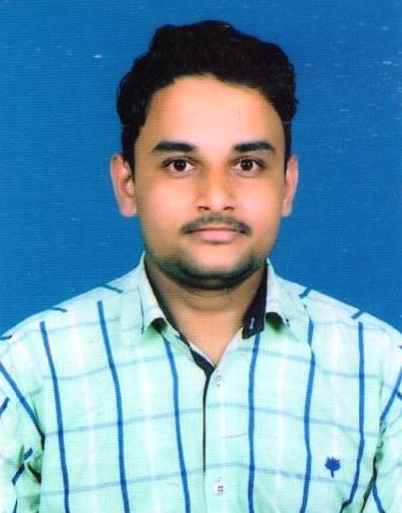
RESUME

SANDEEP SHARMA
Email ID :-sandeepcadd95@gmail.com
Tubewell Colony, Shiv Puri
Dist :- Deoria (U.P.)
274001
Mobile-7206304312
Career Objective :-
- To work in a competitive & challenging work environment to contribute the best of my ability towards the growth and development of a progressive company to fully utilize my interpersonal and academic skills to pursue a challenging and rewarding career.
Key skills :-
- Manpower Handling,
- Rejection Control,
- OEE Calculation,
- TPM,
- 5’S, Kaizen, Poka Yoke,
- Material Planning, Inventory Control, FIFO,
- Lean Manufacturing Tools.
Experience :-
- 2 Years experience in RANANSK STEERING INDIA PVT LTD. in PRODUCTION Department
- Presently working in MAGNETI MARELLI MOTHERSON AUTO SYSTEM PRIVATE LIMITED in PRODUCTION Department
Job Profile :-
- Meeting with operators.
- Allocation and manage of manpower as per requirement.
- Achieve day to day target as per Production plan.
- Handling of Assembly Line.
- Ensuring the achievement of all KPI`s like SAFETY,QUALITY & PRODUCTIVITY targets.
- Arrangement of raw material as per Production plan.
- Responsible for Quality Control, Focus on acceptance / rejection of products as per specification.
- Ensure that maximum utilization of resources.
- Responsible to fill line documents like Check Sheet, Daily Production Sheet, Calibration Sheet, 5M sheet, Tool life record.
- Pokayoke Check Sheet, and Torque meter Check Sheet.
- Achieve shift wise defect free Production to fulfill next customer demand.
- Give On Job Training to new joined associates.
- Responsible for change over for different models and updated change over point check sheet at the time of changeover.
- Tool change and Tool setting as per tool life of Assembly line.
- Ensure 5S and Kaizen activity in shop floor areas.
- To achieve Monthly Suggestion target.
- Rejection Handling and rejection movement as per Scrap Note.
Achievements:-
- Won Highest Attendance Award in 2015-2016.
- Maximum SUGGESTIONS First award in 2015-16.
- Win best KAIZEN Award for Rejection Control
.
Company Profile :-
- MAGNETI MARELLI MOTHERSON AUTO SYSTEM PRIVATE LIMITED
- In the State of Haryana North India in 2008.
- It Manufacture The rear combination lamp(RCL)
- Main Coustomer of Company Are:-
- Maruti Suzuki India. Ltd.
- Honda Moter Company Ltd.
Educational Qualification :-
- Diploma in Mechanical Engg. from Prashad Polytechnic, Lucknow in 2015
- Passed 12th with PCM from Allahabad Board.
- Passed Matriculation from Allahabad Board.

Trainings Attended :-
- Total Productive Maintenance (T.P.M.)
- Fire Safety.
- Training on Problem Solving Tools (7 QC Tools).

Personal Detail :-
- Fathers name : Jai Prakash Sharma
- Date of birth : 01/07/1995
- Marital Status : Unmarried
- Sex : Male
- Languages : English / Hindi
- Nationality : Indian
- Present Add : Rajesh Pilot Chowk Rewari Haryana
Pin-123401
Declaration :-
I hereby declared that the information given by me is true with my knowledge.

DATE:-. (Sandeep Sharma)
PLACE:-

